ADMIN MAIN OFFICE
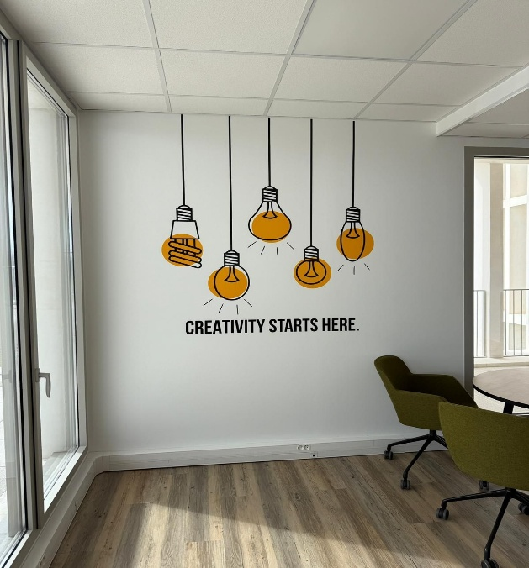
THE LED LIGHTS GETTING CONNECTED WITH BULBS
RECEPTION
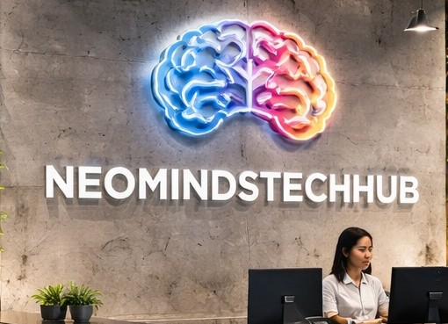
USING STRUCTURE ART MAKE NEOMIND LOGO


LEARN TECH GROW TOGETHER
(REFER LAST PAGE LAST PAGE)
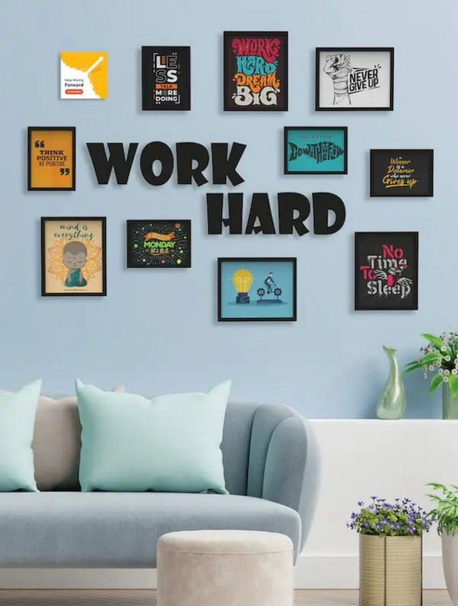

CLASS ROOM
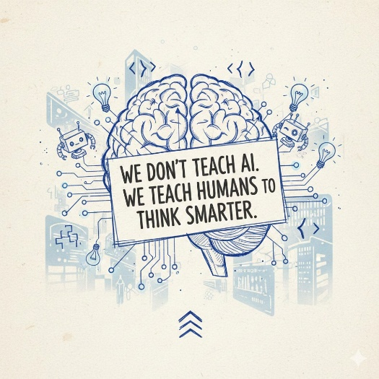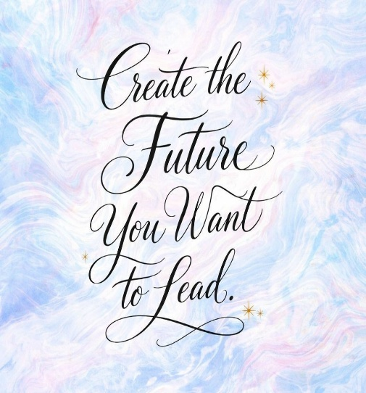
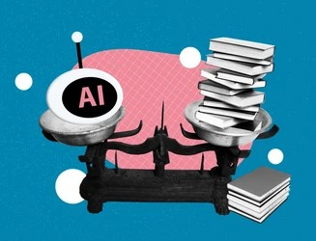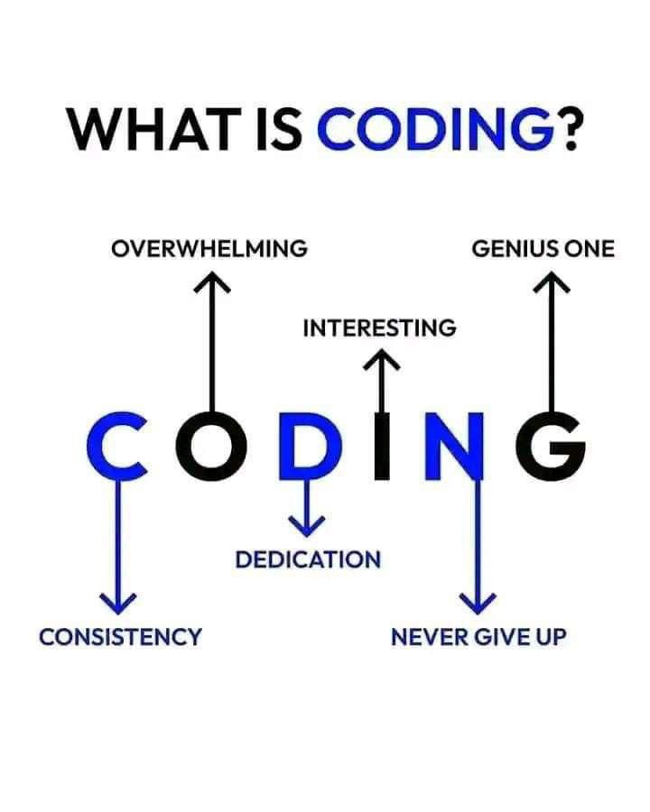
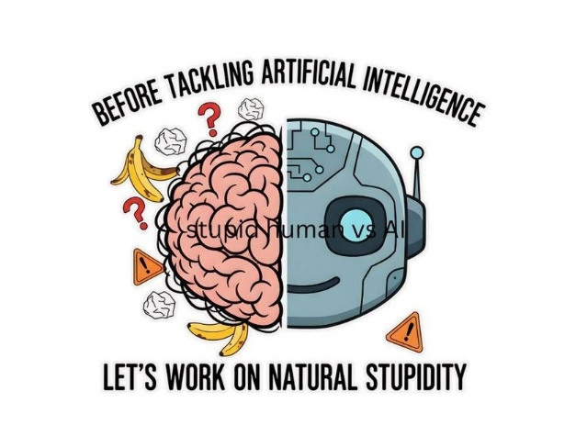

STAFF ROOM
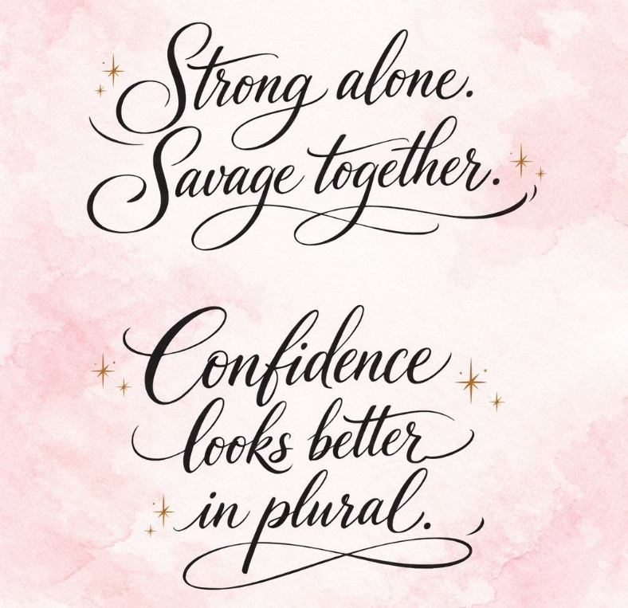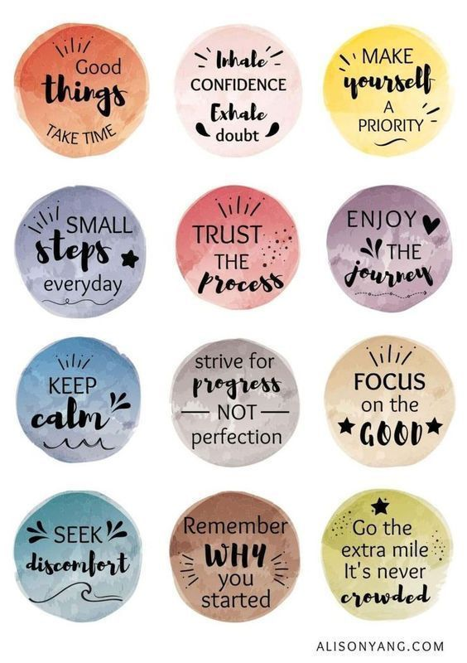
GALLERY
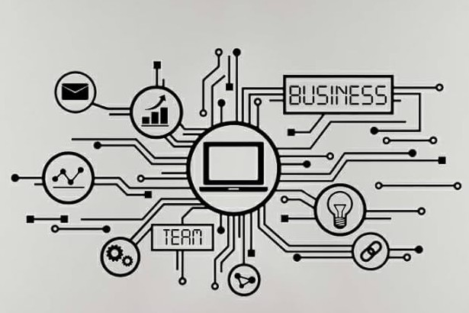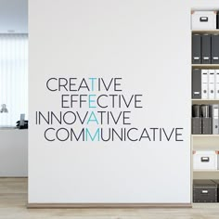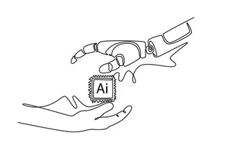

CONFERENCE ROOM
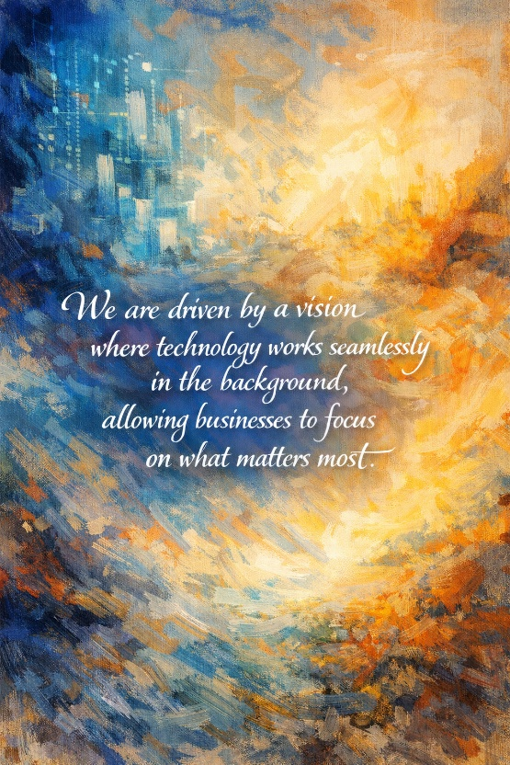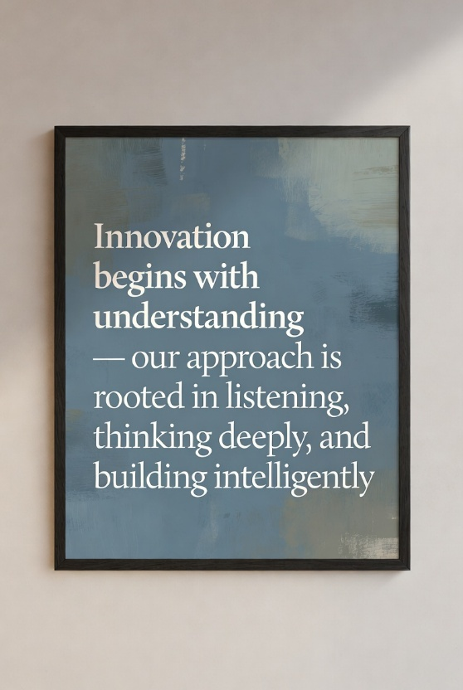
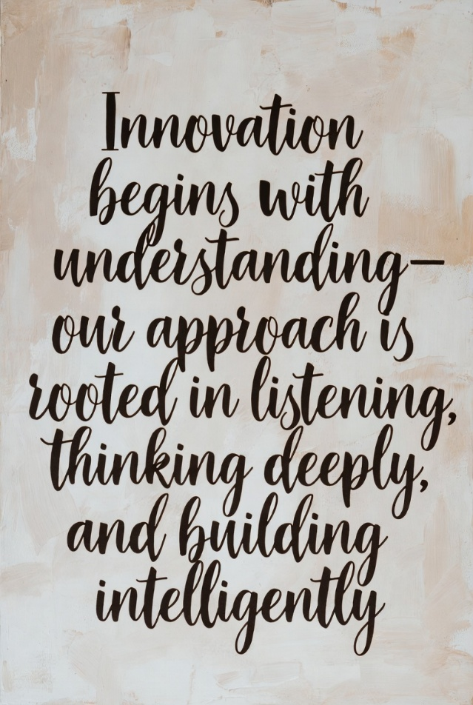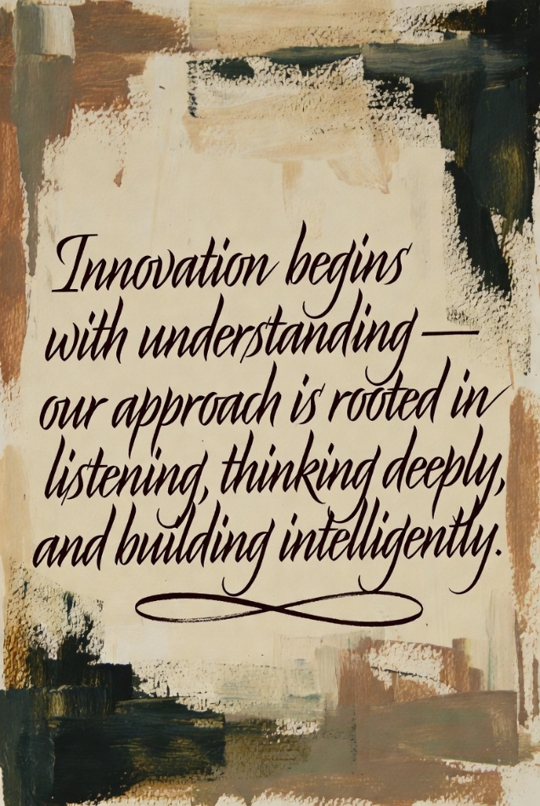
“From idea to execution, we partner with our clients to create intelligent digital products that solve real problems and scale with their business.”
“Every project we build is guided by strategy, enhanced by artificial intelligence, and crafted to deliver long-term impact.”
“We design and build intelligent digital solutions that combine creativity, technology, and artificial intelligence to help businesses grow smarter and faster.”
“We believe technology should do more than function — it should think, adapt, and deliver real value to the people who use it.”
“Our mission is to create digital products that feel simple on the surface, yet powerful at their core.”
“Innovation begins with understanding — our approach is rooted in listening, thinking deeply, and building intelligently.”
“We are driven by a vision where technology works seamlessly in the background, allowing businesses to focus on what matters most.”

LEARN – “We learn relentlessly, because the future is built by curious minds.”
TEACH – “We teach what we learn, turning knowledge into shared power.”
GROW – “We grow by applying ideas, shaping tomorrow with AI and innovation.”
TOGETHER – “Together, we rise—learning, teaching, and growing as one.”
- Learn: Curiosity starts the journey.
- Teach: Sharing multiplies intelligence.
- Grow: Practice transforms potential.
- Together: Unity accelerates the future.
1 – Clean & Inspirational
- LEARN: Learning today prepares us for tomorrow’s intelligence.
- TEACH: Teaching turns individual knowledge into collective strength.
- GROW: Growth happens when ideas meet action.
- TOGETHER: Together, we evolve faster.
2 – Future & AI Focused
- LEARN: We learn to understand the future.
- TEACH: We teach to shape it.
- GROW: We grow by building with AI.
- TOGETHER: Together, we lead innovation.
3 – Community & Self-Learning
- LEARN: Learning sparks endless possibilities.
- TEACH: Helping others learn strengthens us all.
- GROW: Shared effort fuels real growth.
- TOGETHER: Together is where progress lives.
4 – Minimal & Powerful
- LEARN: Stay curious.
- TEACH: Share boldly.
- GROW: Build continuously.
- TOGETHER: Advance as one.
5 – Visionary Flow (Reads beautifully in order)
- LEARN: Knowledge is our foundation.
- TEACH: Guidance is our culture.
- GROW: Innovation is our outcome.
- TOGETHER: Unity is our advantage.

